NAME: AMAN SUHAIL
ID: IU04-0121-0038
COURSE: WEB PROGRAMMING LANGUAGE
PROBLEM BASED LEARNING(PBL)
CRUD WITH SQL INJECTION

CODE:
index.PHP
<?php
$conn = mysqli_connect('localhost', 'root', '', 'wpl');
$query = "select * from products";
$result = mysqli_query($conn, $query);

$data = mysqli_fetch_all($result, MYSQLI_ASSOC);

?>
<!DOCTYPE html>
<html lang="en">

<head>
<meta charset="UTF-8">
<meta http-equiv="X-UA-Compatible" content="IE=edge">
<meta name="viewport" content="width=device-width, initial-scale=1.0">
<title>Document</title>
<script src="bootstrap/js/bootstrap.min.js"></script>
<link rel="stylesheet" href="bootstrap/css/bootstrap.min.css">
</head>

<a href="form.php" class="btn btn-primary"">Create</a>
<body>
<table border ='1' class="table table-bordered table-hover table-striped" >
<thead>
<th>Sr</th>
<th>Product Category</th>
<th>Product Name</th>
<th>Product Price</th>
<th>Product Quantity</th>
<th>Action</th>
</thead>
<tbody>
<?php
for ($i = 0; $i < count($data); $i++) {
?>
<tr>
<td><?php echo $data[$i]['id'] ?></td>
<td><?php echo $data[$i]['product_category'] ?></td>
<td><?php echo $data[$i]['product_name'] ?></td>
<td><?php echo $data[$i]['product_price'] ?></td>
<td><?php echo $data[$i]['product_quantity'] ?></td>
<td>
<a href="edit.php?product_id=<?php echo $data[$i]['id'] ?>">Edit</a>
<a href="delete.php?product_id=<?php echo $data[$i]['id'] ?>">Delete</a>
</td>
</tr>
<?php
}
?>
</tbody>
</table>
</body>

</html>

Form.PHP
<!DOCTYPE html>
<html lang="en">

<head>
<meta charset="UTF-8">
<meta http-equiv="X-UA-Compatible" content="IE=edge">
<meta name="viewport" content="width=device-width, initial-scale=1.0">
<title>Document</title>
<script src="bootstrap/js/bootstrap.min.js"></script>
<link href="https://cdn.jsdelivr.net/npm/bootstrap@5.3.8/dist/css/bootstrap.min.css" rel="stylesheet" integrity="sha384-sRIl4kxILFvY47J16cr9ZwB07vP4J8+LH7qKQnuqkuIAvNWLzeN8tE5YBujZqJLB" crossorigin="anonymous">
</head>

<body>
<div class="container">
<form method="post" action="forrmSubmit.php">
<div class="form-group" style="margin: 10px;">
<label for="">Product </label>
<input type="text" class="form-control" name="product_name" placeholder="Enter product name">
</div>
<div class="form-group" style="margin: 10px;">
<label>Product Category</label>
<input type="text" class="form-control" name="product_category" placeholder="Enter product category">
</div>
<div class="form-group" style="margin: 10px;">
<label>Product Price</label>
<input type="number" class="form-control" name="product_price" placeholder="Enter product price">
</div>
<div class="form-group" style="margin: 10px;">
<label>Product Quantity</label>
<input type="number" class="form-control" name="product_quantity" placeholder="Enter product quantity">
</div>

<input type="submit" class="btn btn-primary" style="margin: 10px;" value="Submit">
</form>
</div>

<script>
function SubmitForm() {
var firstName = document.getElementById('first_name').value;
if (firstName != '') {
firstNameRegex = /^[a-zA-Z]{1,1000}$/
var testFirstName = firstNameRegex.test(firstName)
alert(testFirstName);
} else {
document.getElementById('first_name_error').innerHTML = 'Please insert the value'
}
}
</script>
</body>

</html>

Edit.php
<?php
$id = $_GET['product_id'];

$conn = mysqli_connect('localhost', 'root', '', 'wpl');

$query = "SELECT * FROM products WHERE id = ?";
$stmt = mysqli_prepare($conn, $query);
mysqli_stmt_bind_param($stmt, "i", $id);
mysqli_stmt_execute($stmt);
$result = mysqli_stmt_get_result($stmt);

$data = mysqli_fetch_all($result, MYSQLI_ASSOC);

mysqli_stmt_close($stmt);
mysqli_close($conn);
?>
<!DOCTYPE html>
<html lang="en">

<head>
<meta charset="UTF-8">
<meta http-equiv="X-UA-Compatible" content="IE=edge">
<meta name="viewport" content="width=device-width, initial-scale=1.0">
<title>Document</title>
<script src="bootstrap/js/bootstrap.min.js"></script>
<link rel="stylesheet" href="bootstrap/css/bootstrap.min.css">
</head>

<body>
<div class="container">
<form method="post" action="editForrmSubmit.php">
<div class="form-group" style="margin: 10px;">
<input value="<?php echo $data[0]['id']?>" type="hidden" class="form-control" name="product_id" placeholder="Enter product name">
</div>
<div class="form-group" style="margin: 10px;">
<label for="">Product Name</label>
<input value="<?php echo $data[0]['product_name']?>" type="text" class="form-control" name="product_name" placeholder="Enter product name">
</div>
<div class="form-group" style="margin: 10px;">
<label>Product Category</label>
<input value="<?php echo $data[0]['product_category']?>" type="text" class="form-control" name="product_category" placeholder="Enter product category">
</div>
<div class="form-group" style="margin: 10px;">
<label>Product Price</label>
<input value="<?php echo $data[0]['product_price']?>" type="number" class="form-control" name="product_price" placeholder="Enter product price">
</div>
<div class="form-group" style="margin: 10px;">
<label>Product Quantity</label>
<input value="<?php echo $data[0]['product_quantity']?>" type="number" class="form-control" name="product_quantity" placeholder="Enter product quantity">
</div>

<input type="submit" class="btn btn-primary" style="margin: 10px;" value="Submit">
</form>
</div>

<script>
function SubmitForm() {
var firstName = document.getElementById('first_name').value;
if (firstName != '') {
firstNameRegex = /^[a-zA-Z]{1,1000}$/
var testFirstName = firstNameRegex.test(firstName)
alert(testFirstName);
} else {
document.getElementById('first_name_error').innerHTML = 'Please insert the value'
}
}
</script>
</body>

</html>

Formsubmit.php
<?php
$conn = mysqli_connect('localhost', 'root', '', 'wpl');

if (!$conn) {
die("Connection failed: " . mysqli_connect_error());
}

$product_name = $_POST['product_name'];
$product_category = $_POST['product_category'];
$product_price = $_POST['product_price'];
$product_quantity = $_POST['product_quantity'];

$stmt = mysqli_prepare($conn, "INSERT INTO products(product_name, product_category, product_price, product_quantity) VALUES (?, ?, ?, ?)");

mysqli_stmt_bind_param($stmt, "ssdi", $product_name, $product_category, $product_price, $product_quantity);

if (mysqli_stmt_execute($stmt)) {
mysqli_stmt_close($stmt);
mysqli_close($conn);
header('Location: index.php');
exit();
} else {
echo "Error: " . mysqli_error($conn);
}
?>

Editforrmsubmit.php
<?php

$conn = mysqli_connect('localhost', 'root', '', 'wpl');

if (!$conn) {
die("Connection failed: " . mysqli_connect_error());
}

$id = $_POST['product_id'];
$product_name = $_POST['product_name'];
$product_category = $_POST['product_category'];
$product_price = $_POST['product_price'];
$product_quantity = $_POST['product_quantity'];

$stmt = mysqli_prepare($conn, "UPDATE products SET
product_name = ?,
product_category = ?,
product_price = ?,
product_quantity = ?
WHERE id = ?");

mysqli_stmt_bind_param($stmt, "ssdii", $product_name, $product_category, $product_price, $product_quantity, $id);

if (mysqli_stmt_execute($stmt)) {
mysqli_stmt_close($stmt);
mysqli_close($conn);
header('Location: index.php');
exit();
} else {
echo "Error updating record: " . mysqli_error($conn);
}

?>

Delete.php
<?php

$conn = mysqli_connect('localhost', 'root', '', 'wpl');

if (!$conn) {
die("Connection failed: " . mysqli_connect_error());
}

$id = $_GET['product_id'];

$stmt = mysqli_prepare($conn, "DELETE FROM products WHERE id = ?");

mysqli_stmt_bind_param($stmt, "i", $id);

if (mysqli_stmt_execute($stmt)) {
mysqli_stmt_close($stmt);
mysqli_close($conn);
header('Location: index.php');
exit();
} else {
echo "Error deleting record: " . mysqli_error($conn);
}

?>

OUTPUT:

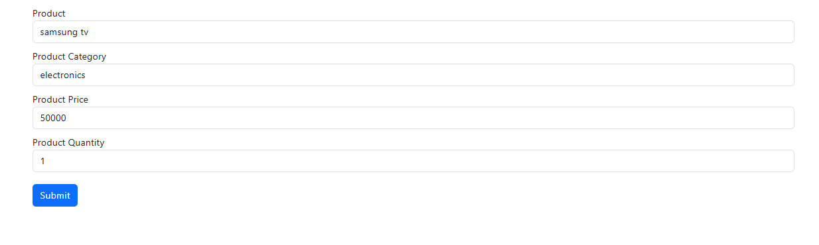
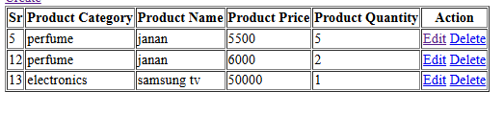

Edit form
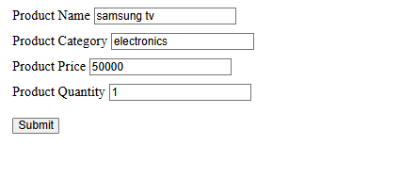
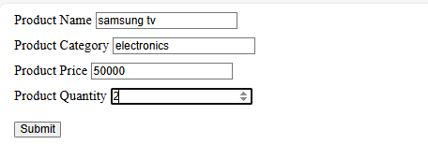
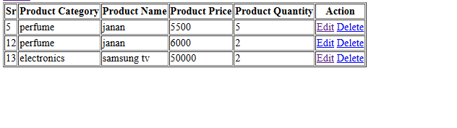
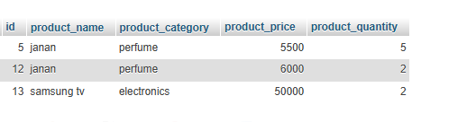
Delete:
